0

**ONLINE FAST-FOOD ORDER SYSTEM**

**A Project Report**

Submitted in partial fulfillment of the Requirements for the award of the Degree of

**BACHELOR OF SCIENCE (INFORMATION TECHNOLOGY)**

**By**

Tejas More

Seat Number

**Under the esteemed guidance of**

**Asst. Prof. Harshada Nage.**

**Assistant Professor**



**DEPARTMENT OF INFORMATION TECHNOLOGY**

**I.C.S. COLLEGE OF ARTS, COMMERCE & SCIENCE, KHED**

***(Affiliated to University of Mumbai)***

**KHED, 415 709**

**MAHARASHTRA**

**2020-2021**

**I.C.S. COLLEGE OF ARTS, COMMERCE & SCIENCE, KHED**

***(Affiliated to University of Mumbai)***

**KHED-MAHARASHTRA-415 709**

**DEPARTMENT OF INFORMATION TECHNOLOGY**



**CERTIFICATE**

This is to certify that the project entitled, **"Online Fast-Food Order System"**, is bonafied work of **Tejas More** bearing Seat No: __________ submitted in partial fulfillment of therequirements for the award of degree of BACHELOR OF SCIENCE in INFORMATION TECHNOLOGY from University of Mumbai.

**Internal Guide** **Coordinator**

**External Examiner**

**Date:** **College Seal**

**ABSTRACT**

An online Fast Food Order Store permits a customer to submit online orders for items and services from a store that serves both walk-in customers and online customers. The online Store system presents an online display of all the items they want to sell. This web-based application helps customers to choose their products and add products to their shopping cart. Customers provide their complete detail of address and contact and they get their chosen products in their home.

Shopping carts may be examined at any time, and their contents can be edited or deleted at the option of the customer. Once the customer decides to submit a purchase order, the customer may print the contents of the shopping basket in order to obtain a hard copy record of the transaction.

This Web application saves lots of time of customers and give the more advantages to customer.

**ACKNOWLEDGEMENT**

It is my prime duty to offer my sincere gratitude to University Of Mumbai to include the project work in the syllabus of Third Year Bachelor’s Degree so as to develop interest about research work among the students like us.

I also grateful to **Dr. G. B. Sarang** Principal of **I.C.S College of Arts Commerce’s and Science**, Khed for providing all necessary facilities of laboratory and library atI.C.S. College, Khed.

I wish to express my sincere thanks to **Dr. Sachin S. Bhosale**, Head of the Department for giving me the opportunity to complete the project work by providing facilities in the department and providing valuable guidance to complete the task and also thanks to my guide **Asst. Prof. Harshada Nage.** to guide me for this project.

Last but not the least my special thanks to my parents, my friends and all those people who have encouraged me, helped me to complete this course successfully in time.

**Yours faithfully,**

Tejas More

TY BSC IT

**DECLARATION**

I hereby declare that the project entitled**, “Online Fast-Food Order System” working in an Academic Year 2021-2022 done at I.C.S. College Of Arts, Commerce & Science, Khed**, has not been in any case duplicated to submit to any other university for the awardof any degree. To the best of my knowledge other than me, no one has submitted to any other university.

The project is done in partial fulfillment of the requirements for the award of degree of **BACHELOR OF SCIENCE (INFORMATION TECHNOLOGY)** to be submitted asfinal semester project as part of our curriculum.

Tejas More

|  |  |  |
| --- | --- | --- |
| **Table Of Content** | | |
| **Sr.**  **No.** | **Phase Name** | **Page No.** |
| **A** | **Preliminary Investigation** |  |
| 1 | Introduction | 10 |
| 1.1 | Background | 11 |
| 1.2 | Objectives | 12 |
| 1.3 | Purpose and Scope | 13 |
| **B** | **System Analysis** |  |
| 2.1 | Existing System | 15 |
| 2.2 | Fact Finding Techniques | 16 |
| 2.3 | Proposed System | 18 |
| 2.4 | Feasibility Study | 18 |
| 2.5 | Requirement Analysis | 20 |
| 2.6 | Hardware Requirements | 21 |
| 2.7 | Software Requirements | 21 |
| 2.8 | Gantt Chart | 22 |
| 2.9 | Justification of selection of Technology | 23 |
| **C** | **System Design** |  |
| 3.1 | Module Division | 25 |
| 3.2 | Data Dictionary | 26 |
| 3.3 | ER Diagrams | 29 |
| 3.4 | DFD/UML Diagrams | 30 |
| **D** | **Implementation and Testing** |  |
| 4.1 | Testing Approach | 45 |
| **E** | **Results and Discussions** |  |
| 5.1 | Screen Layout | 48 |
| **F** | **Conclusion and Future Work** |  |
| 6.1 | Conclusion | 60 |
| 6.2 | Future Work | 61 |
| **G** | **References** |  |

|  |  |  |
| --- | --- | --- |
| **List Of Figures** | | |
| **Sr. No.** | **Name Of The Figures** | **Page No.** |
| 1 | Entity Relation Diagram | 29 |
| 2 | Data Flow Diagram | 30 |
| 3 | Use Case Diagram | 34 |
| 4 | Activity Diagram | 39 |
| 5 | Sequence Diagram | 41 |
| 6 | Class Diagram | 43 |

|  |  |  |
| --- | --- | --- |
| **List Of Tables** | | |
| **Sr. No.** | **Name Of The Tables** | **Page No.** |
| 1 | Products Table | 27 |
| 2 | Orders Table | 27 |
| 3 | Cart Table | 27 |
| 4 | Registration Table | 28 |

PRELIMINARY

INVESTIGATION

**Introduction**

The main aim for developing this project where customer can purchase and order Fast Food Orders online. The system is very useful for customer can easily buy the Fast-Food Orders products from home through internet. The system reduces lots of work load for customer. By this system online Fast-Food Order shopping the product is directly delivered to customer address.

The system functionality of products and orders is stored on the admin side in a web service. This project provides a lot of features to manage the products in very well manner. This project contains a lot of advance modules which makes the back-end system very powerful.

Online Fast Food Order Market is a form of ecommerce that allows customers to directly buy a product from a seller over the internet.

The System will have these basic functions:

• Customer Information.

• Catalogue of items sold or available in the store.

• Hold client shopping preference in a database.

• Interface for customer support or relations.

• Delivery capabilities.

Background

Sellers in local markets currently have a traditional system of shopping where customers are expected to walk to the displayed items to make purchases at that particular time. This leaves these sellers at the mercy of undecided customers who are normally moved by the competitive pricing of other shops.

Customers who are loyal to the particular sellers are the ones who tend to stay for years with unwavering attachment to such sellers. Most sellers in the market places do not have a database of customers who visit. Customers basically walk-in just buy what they need and they are gone.

There is a simple work flow of acquiring various products from the wholesalers, working out prices, displaying produce on the shelves, receiving money, bagging bought items and finally watch the customer walk away without out any interaction. This leaves no room for feedback from the customer on the shopping experience. Whether it was good or bad it will never be known until an unhappy customer willingly comes out to complaint.

Objectives

The aim of this project it to give information about the content of any Fast-Food Order System to anyone who so wants to check current prices of available products, order products, spend less time in the Online Fast Food Order Management System to reduce the stress and hustle of shopping and finding of

customers.

The Objectives of using an Online Fast Food Order Management System are to:

* Provide accessible information about products to customers who have are cut off by

distance of other constrains but need to shop then can buy online product delivery.

* To minimize the difficulty of business owners from finding customers and reducing

The cost of advertisement which are paid to most radio and television stations who

genuinely allocate smallest of their broadcast time to such broadcast.

* Eliminate the unwanted petrol of shoppers who take up space in various

stores and markets. This goes a long way to reduce human traffic in our markets.

* Extremely minimize the losses due to shoplifting and cost associated with security.

Purpose and Scope

* Purpose:

Online shopping tries to enhance access to care and improve the continuity and efficiency of services. Depending on the specific setting and local case managers are responsible for a variety of tasks, ranking from linking clients to services to actually providing intensive shopping and delivery services themselves.

Main Objectives:

* To shop while in the comfort of your own home, without having to step out of the door.
* Sell at lower rate due to less overhead.
* Provide home delivery free of cost.
* No wait to see the products if someone else is taking that.
* Scope:

This product has great future scope. Online Fast Food Order Management Internet software developed on and for the Windows and later versions of environments. This project also provides security with the use of Login-Id and Password, so that any unauthorized users cannot use your account. The only Authorized that will have proper access authority can access the software.

SYSTEM

ANALYSIS

**Existing System**

Many customers go for purchasing offline so as to examine the product and hold the possession

of the product just after the payment for the product. In this contemporary world customers

loyalty depends upon the consistent ability to deliver quality, value and satisfaction. Offline

shopping has a sense of immediacy.

Limitation of Existing System:

* Time Consuming
* Shipping Rates
* Refunds/Returns Disputes
* Lack of options
* Cash-Back offers not present
* Bad customer service

**FACT FINDING SYSTEM**

Fact-finding technique is one of the parts of the system analysis. At the time of analysis of the system or before starting actual work, system analysts collect the information. For gathering information system analyst prefers any fact-finding technique such as

1] Interview

2] Questionnaire

3] Observation

While developing this system we have done this part by using interview & questionnaires techniques.

**1] Interview: -**

The whole system investigation part has done by taking interview of the concerned people, user & staff. By asking them manual process of each work, by pointing hints regarding the work, by discussing their problems deeply, by asking them their requirements, by taking their valuable suggestion guidance regarding system study.

After taking their interviews regarding the systems study noting down the points regarding the system. This work of taking interview-asking difficulties to concern person till all the points of the system understood. This interview technique proved beneficial outcome for system analysis.

**2] Questionnaire: -**

In this method we actually provide a list of questions to the user. According to the list the user answers the questions, taking his own time without stress to answer quickly. In this method the results Obtained are rather accurate and thoughtfully given. Questionnaires can be an effective method for gathering facts.

E.g., how your system actually works?

**3] Observation: -**

This technique proves useful in finding the facts of the system. In this technique has done by observing ledger, registers, document, files that are prepared manually.

**Proposed System**

To overcome all these problems that is mentioned in existing system, we are developing a solution that is, instead of go in shopping mall and store, we can search for the item using our mobile, through internet make shopping easy. Delivery options are added in system that’s help for customer. We can add products also delete in cart. The best service gives to customer and cash on delivery available that’s makes a helpful system to customer.

Feasibility Study

After doing the project Fast Food Order Management System, study and analyzing all the existing or required functionalities of the system, the next task is to do the feasibility study for the project. All projects feasible – given unlimited resources and infinite time.

Feasibility study includes consideration of all the possible ways to provide a solution to the given problem. The proposed solution should satisfy all the user requirements and should be flexible enough so that future changes can be easily done based on the future upcoming requirements.

A. Economic Feasibility

This is very important aspects to be considered while developing a project. We decided the technology based on minimum possible cost factor.

* All hardware and software cost has to be done by developer.
* Overall, we have estimated that the benefits the developer is going to receive from the proposed system will surely overcome the initial costs and the later on running cost for system.

B. Technical Feasibility

This includes the study of function, performance and constraints that may affect the ability to achieve an acceptable system. For this feasibility study, we studied complete functionality to be provided in the system, as described in the System Requirement Specification (SRS), and checked if everything was possible using different type of frontend and backend platforms.

C. Operational Feasibility

No doubt the proposed system is fully GUI based that is very user friendly and all inputs to be taken all self-explanatory even to a layman. Besides, a proper training has been conducted to let know the essence of the system to the users so that they feel comfortable with new system. As far our study is concerned the clients are comfortable and happy as the system has cut down their loads and doing.

**Requirement Analysis**

**1) Problem Definition:**

Drawbacks of System:

1. Time consuming.
2. More expensive.
3. Searching problem.
4. Maintains problem of all registers.
5. Less accuracy.
6. Problem for marking of not normal value.
7. More stationary.
8. Display multiple reports.

**2) System Requirement & Specification:**

System analysis is a process of gathering and interpreting facts, and the information about the Online Fast Food Order Management System to recommend improvements on the system. It is a problem-solving activity that requires intensive communication between the system users and system developers. System analysis or study is an important phase of any system development process. The system is viewed as a whole and traced to the various processes. Such system analysis is concerned with becoming aware of the problem, identifying the relevant and decisional variables.

Advantages of computerized system

1. Time saving.
2. Less expensive.
3. Powerful searching.
4. Solve the problem of maintains register.
5. More accuracy.
6. Easy generate report.

**System Requirements**

1. Hardware Requirements:

* The general specifications are as follows:
* 50 GB free space on hard disk.
* Intel dual core or above
* 4 GB RAM.
* Operational System:
* WINDOWS XP & Above

1. Software Requirements:

* Front End: ASP .NET WITH C#
* Back End: SQL

**GANTT CHART**

|  |  |  |  |
| --- | --- | --- | --- |
| **Name of the Phase** | **Expected Date of Completion** | **Actual Date of Completion** | **Signature of Guide** |
| Project Search |  |  |  |
| Finalization and Allocation |  |  |  |
| Investigating of System Requirements |  |  |  |
| Data & Process Modelling |  |  |  |
| System Design |  |  |  |
| Program Design |  |  |  |
| Program Coding and Unit Testing |  |  |  |
| System Integration |  |  |  |
| Project review by Guide |  |  |  |
| System Implementation |  |  |  |
| Acceptance Testing |  |  |  |
| Feedback for improving correction and modifying Project |  |  |  |

**Justification of selection of Technology**

**Front End: ASP .NET WITH C#**

* Keep you Asp.net applications secured with the built-in Windows authentication and per-application configuration.
* Asp.net has reduced the long lines of code required to develop large applications.
* Asp.net and Html, together generate dynamic web pages smoothly.
* Being an ideal server-side scripting technology, Asp.net code first runs on Windows server before displaying on the web browser.
* Asp.net framework is language independent, means you can choose any programming language which best suited to you application.
* Cross platform and container support and give high performance.
* It is user friendly language which performs all tasks with simplicity.

**Back End: SQL**

* SQL are easy to implement, because they use a simple high level, strongly typed language.
* SQL functions are more reliable than equivalent external functions.
* Supports input parameters.
* SQL scalar functions return a scalar value.
* SQL table functions return a table result set.

**System**

**Design**

**Module Division**

**Module of the software:**

* **Login:** Admin can choose his own username and password. After logging into the system, he can provide username and password to other unauthorized users.
* **Order:** The order from the dealer is taken through phone and the products; quality is entered by an employee. It will be saved in the database and a crystal report will generated for billing purpose.
* **Stock:** After manufacturing, the products will be sent to the stock. Here we can get the total number of products available.
* **Customer:** Check the all products and give order of products. Check order status and see recently add cart products.
* **Product:** Detail information about product which is provided by admin.

**Data Dictionary**

This is normally represented as the data about data. It is also termed as metadata some times which gives the data about the data stored in the database. It defines each data term encountered during the analysis and design of a new system. Data elements can describe files or the processes.

Following are some major symbols used in the data dictionary

• = equivalent

• + and

• [] either/ or

• () optional entry

Following are some rules, which defines the construction of data dictionary entries:

1. Words should be defined to understanding for what they need and not the variable needs

by which they may be described in the program.

2. Each word must be unique. We cannot have two definitions of the same client.

3. A vendor number may also be called as customer number.

4. A self-defining word should not be decomposed.

Data dictionary includes information such as the number of records in file, the frequency a process will run, securely factor like password which user must enter to get excess to the information.

Products Table:

|  |  |  |  |  |  |
| --- | --- | --- | --- | --- | --- |
| **Sr. No.** | **Name** | **Data Type** | **Size** | **Constraints** | **Description** |
|  | Id | Int |  | Primary key | Holds product id |
|  | Category | Varchar | 50 | Not null | Hold the category |
|  | Name | Varchar | 50 | Not null | Holds the name |
|  | Price | Varchar | 50 | Not null | Holds the price |
|  | Image | Varchar | 50 | Not null | Holds the image |
|  | Stock | Varchar | 50 | Not null | Holds the stock |

Orders Table:

|  |  |  |  |  |  |
| --- | --- | --- | --- | --- | --- |
| **Sr. No.** | **Name** | **Data Type** | **Size** | **Constraints** | **Description** |
|  | O_Id | Int |  | Primary key | Holds the product id |
|  | Session_Id | Varchar | 50 | Not null | Holds the session id |
|  | C_name | Varchar | 20 | Not null | Holds customer name |
|  | C_ phone | Varchar | 50 | Not null | Holds phone no |
|  | C_email | Varchar | 50 | Not null | Holds email id |

Cart Table:

|  |  |  |  |  |  |
| --- | --- | --- | --- | --- | --- |
| **Sr. No.** | **Name** | **Data Type** | **Size** | **Constraints** | **Description** |
|  | Id | Int |  | Primary key | Holds the cart id |
|  | Product Id | Int |  | Foreign key | Holds product id |
|  | Session Id | Varchar | 50 | Not null | Holds session id |
|  | Name | Varchar | 50 | Not null | Holds product name |
|  | image | Varchar | 50 | Not null | Hold product image |
|  | category | Varchar | 50 | Not null | Hold product category |
|  | Price | Int |  | Not null | Holds product price |
|  | Quantity | Varchar | 50 | Not null | Holds product quantity |
|  | Net Price | Int |  | Not null | Holds product price |
|  | Cart Total | Int |  | Not null | Holds cart total |

Registration Table:

|  |  |  |  |  |  |
| --- | --- | --- | --- | --- | --- |
| **Sr. No.** | **Name** | **Data Type** | **Size** | **Constraints** | **Description** |
|  | User_Id | Int |  | Primary key | Holds user id |
|  | First | Varchar | 50 | Not null | Holds first name |
|  | Last | Varchar | 50 | Not null | Holds last name |
|  | Mobile | Varchar | 50 | Not null | Holds mobile no |
|  | Gender | Varchar | 50 | Not null | Holds gender |
|  | Address | Varchar | 50 | Not null | Holds customer Address |
|  | Email | Varchar | 50 | Not null | Holds customer email |
|  | image | Varchar | 50 | Not null | Holds customer image |
|  | password | Varchar | 50 | Not null | Holds customer password |

**ER Diagram**

**Login**

**has**

**Give**

**Manage**

**Order**

**admin**

**Customer**

**view**

**Registration**

**Cart**

**Manage**

**Product**

**Data Flow Diagram**

Context level DFD: 0 level

Request for Registration

Request for login

USER

Response

ADMIN

Response

1st Level Admin Side DFD:

Request for login

### 

Checkforlogin

Login

### 

AdminMst

response

Admin

### 

Reply

Update stock

Manage stock

Check stock

Reply StockMst

Response

Add/ edit item

Manage item

Insert data

ItemMst

Response

Reply

### 

Manage order

Manage order

### View order OrderMst

Manage customer

### Response Reply

### 

Update customer

Manage customer

CustomerMst

Reply

Response

2nd level Admin DFD

Check detail

Request for login

Login

Admin

AdminMst

Reply

Response

OrderMst

PaymentMst

ItemMst

UserMst

Reply

Reply

Reply

Reply

Resquest

Resquest

Resquest

Resquest

Payment Report

User Report

Item Report

Order Report

User side 1st level DFD:

ItemMst

User

User 2nd Level DFD:

PaymentMst

OrderMst

ItemMst

UserMst

UserMst

UserMst

OrderMst

OrderMst

ItemMst

UserMst

Reply

Request for Login

User

Edit Profile

Update Password

Request for View

Check Details

Reply

Reply

Reply

Reply

**USECASE DIAGRAM**

USE CASE DIAGRAM ADMIN SIDE

Online Fast-Food Order Management System

Manage products Record subsystem

Manage login record subsystem

sxss

Manage customer record subsystem

Manage order subsystem

Manage payment subsystem

Admin

Use Case Subsystem

1. **Manage Customer Record Subsystem**

**<<**uses**>>**

<<extends>>

Admin

**<<**extends**>>**

1. **Manage login Record Subsystem**

<<uses>>

<<extends>>>

<<extends>>

Admin

1. **Manage Product Record Subsystem**

<<uses>>

<<extends>>

<<extends>>

Admin

1. **Manage order record Subsystem**

<<extends>>

<<extends>>

Admin

1. **Manage stock record Subsystem**

<<extends>>

<<extends>>

Admin

<<extends>>

USE CASE DIAGRAM CUSTOMER SIDE

**Activity Diagram**

Customer

Activity Diagram for User Side

Logout

Customer Report

Change password

My Account

Order Report

Search Product

Edit Profile

View Report

Check

Authentication

Login

Invalid

Valid

Add to cart

Cancel Order

Cash on delivary

Make Order

Confirm Report

Activity Diagram for Admin Side

Authentication

Login

Check

Invalid

Valid

Logout

Confirm Order

Edit Item

Change Price

Manage stock

Manage order

Add item

Manage user

Add Category

Active /Inactive user

Update Stock

Modify Details

Manage payment



Sequence Diagram

Admin side sequence diagram:

Manage payment

Logout

Manage order

Manage customer

Sign In

Manage stock

Add Product

**SignIn**

Admin

1: uname()

3: valid()

5: Manage stock()

4: invalid() 6: manage customer()

7: manage order()

8: manage payment()

9: logout()

Customer side sequence Diagram:

Sign in

Customer

home

Order

Add to cart

View product

Logout

Payment

View product()

4: invalid()

2:pass()

Logout()

Do payment()

Give order()

Add to cart()

3: valid()

1: uname

Admin

Class Diagram:



**TESTING**

**Testing**

**Testing Approach**

**UNIT TESTING**

**Unit Testing** is a level of software testing where individual units/ components of a software are tested. The purpose is to validate that each unit of the software performs as designed. A unit is the smallest testable part of any software. It usually has one or a few inputs and usually a single output. In procedural programming, a unit may be an individual program, function, procedure, etc. In object-oriented programming, the smallest unit is a method, which may belong to a base/ super class, abstract class or derived/ child class. (Some treat a module of an application as a unit. This is to be discouraged as there will probably be many individual units within that module.) Unit testing frameworks, drivers, stubs, and mock/ fake objects are used to assist in unit testing.

* Live Unit Testing is a technology available in Visual Studio 2012 that executes your unit tests automatically in real time as you make code changes. Live Unit Testing:
* Let’s you refactor and change code with greater confidence. Live Unit Testing automatically executes all impacted tests as you edit your code to ensure that your changes do not break tests.
* Indicates whether your unit tests adequately cover your code and shows code not covered by unit tests. Live Unit Testing graphically depicts code coverage in real time so that you can see at a glance both how many tests cover each line of code and which lines are not covered by any unit tests.
* Starting with Visual Studio 2012, Live Unit Testing includes improvements and enhancements in a number of areas:
* **Improved discoverability**. For users who do not know that the Live Unit Testing feature exists, the Visual Studio IDE shows a gold bar that mentions Live Unit Testing whenever the user opens a solution that includes unit tests but Live Unit Testing is not enabled. The information presented in the gold bar allows the user to learn more about Live Unit Testing and to enable it. The gold bar also displays information when Live Unit Testing prerequisites are not met. These include:
  + Test adapters are missing.
  + Older versions of test adapters are present.
* **Integration with Task Center notifications**. The Visual Studio now shows a Live Unit Testing background processing notification in Task Center so that users can easily tell what is happening when Live Unit Testing is enabled. This addresses the key problem of starting Live Unit Testing on a large solution. Previously, for a few minutes until the coverage icons appeared, users couldn’t determine whether Live Unit Testing was really enabled and whether it was working. Not anymore!
* **Reliability & Performance**: Live Unit Testing now ensures that the system can better detect when projects haven’t completed loading fully and avoids crashing Live Unit Testing. Build performance improvements also avoid reevaluating MS Build projects when the system

**SCREEN LAYOUT**

Home Page

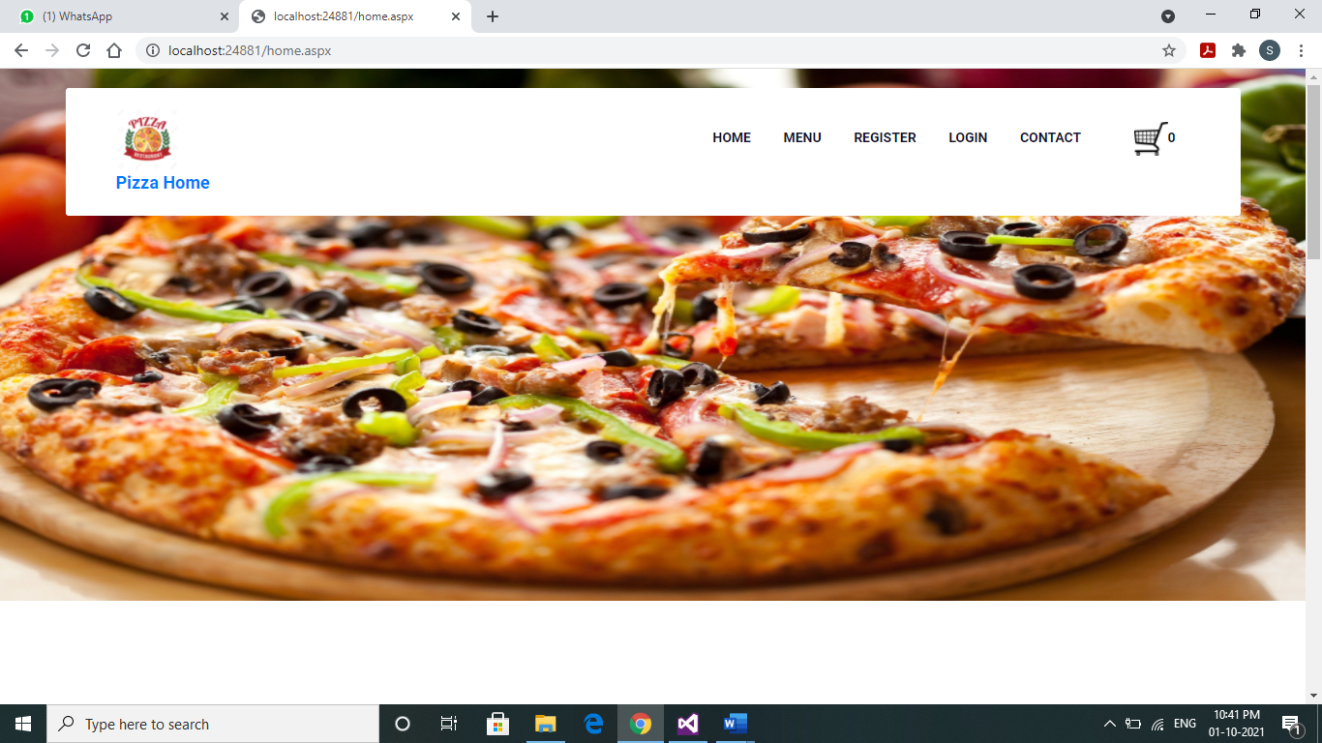

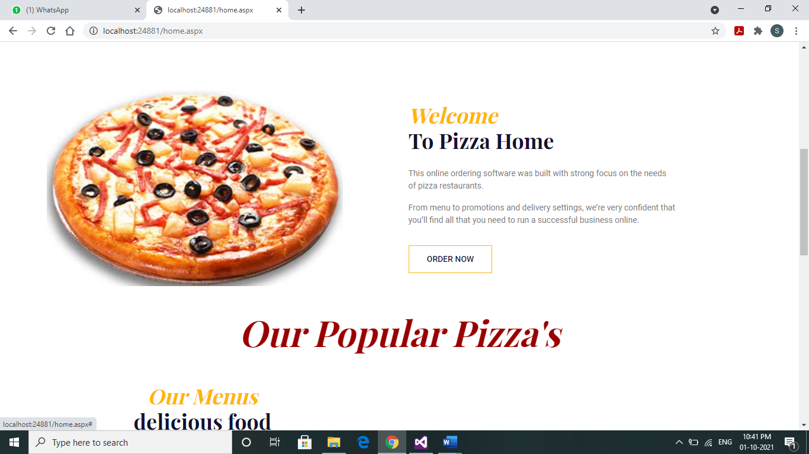

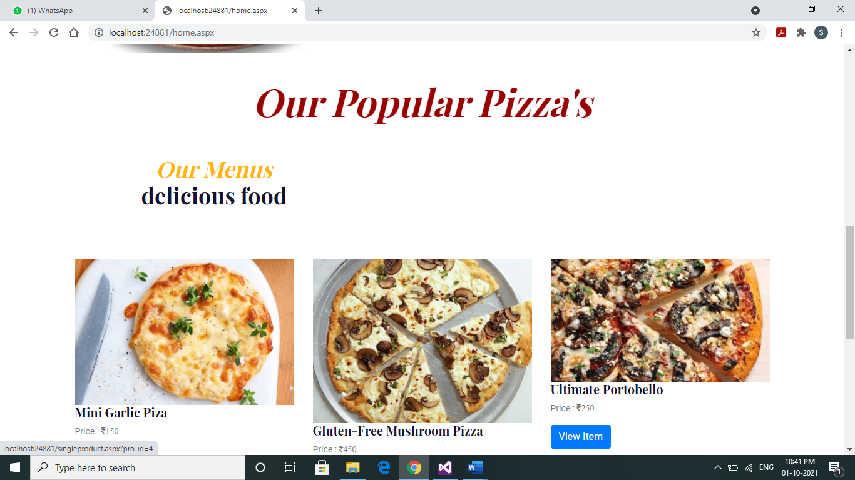

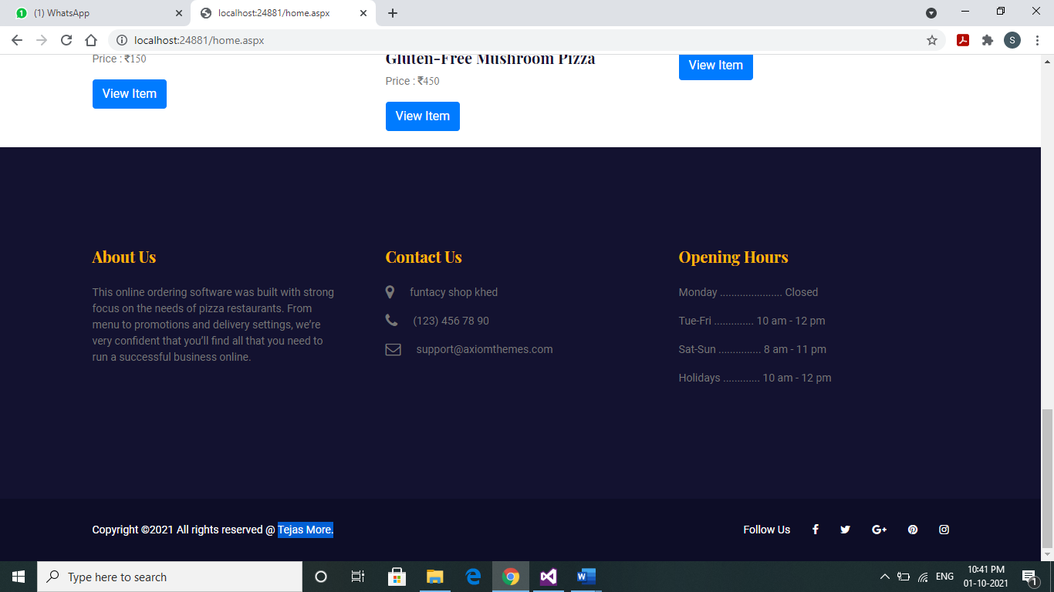

Menus Lists

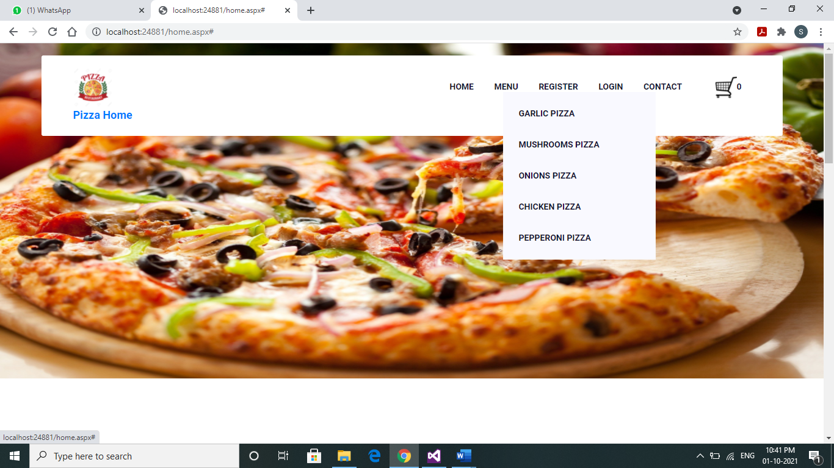

User Registration

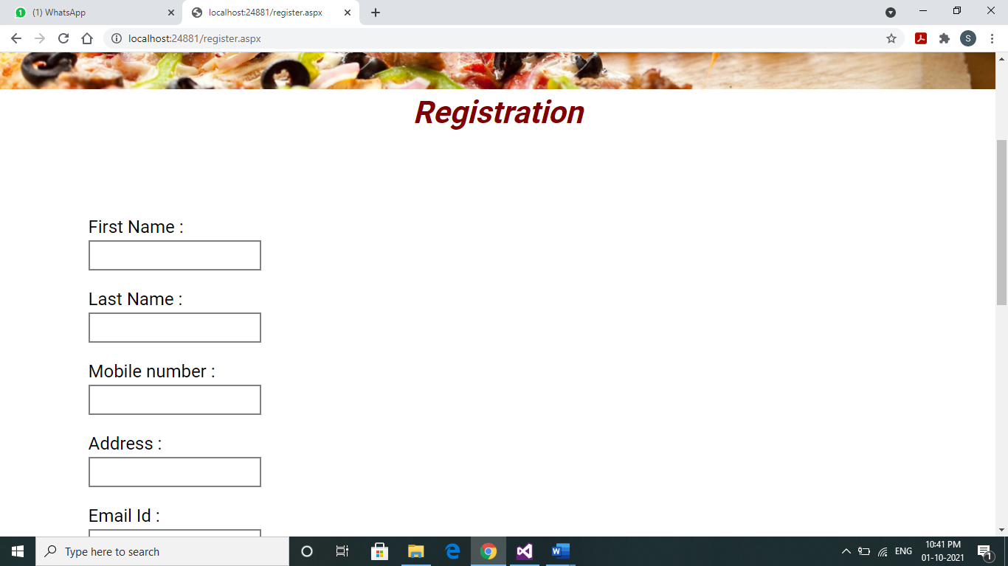

User Login

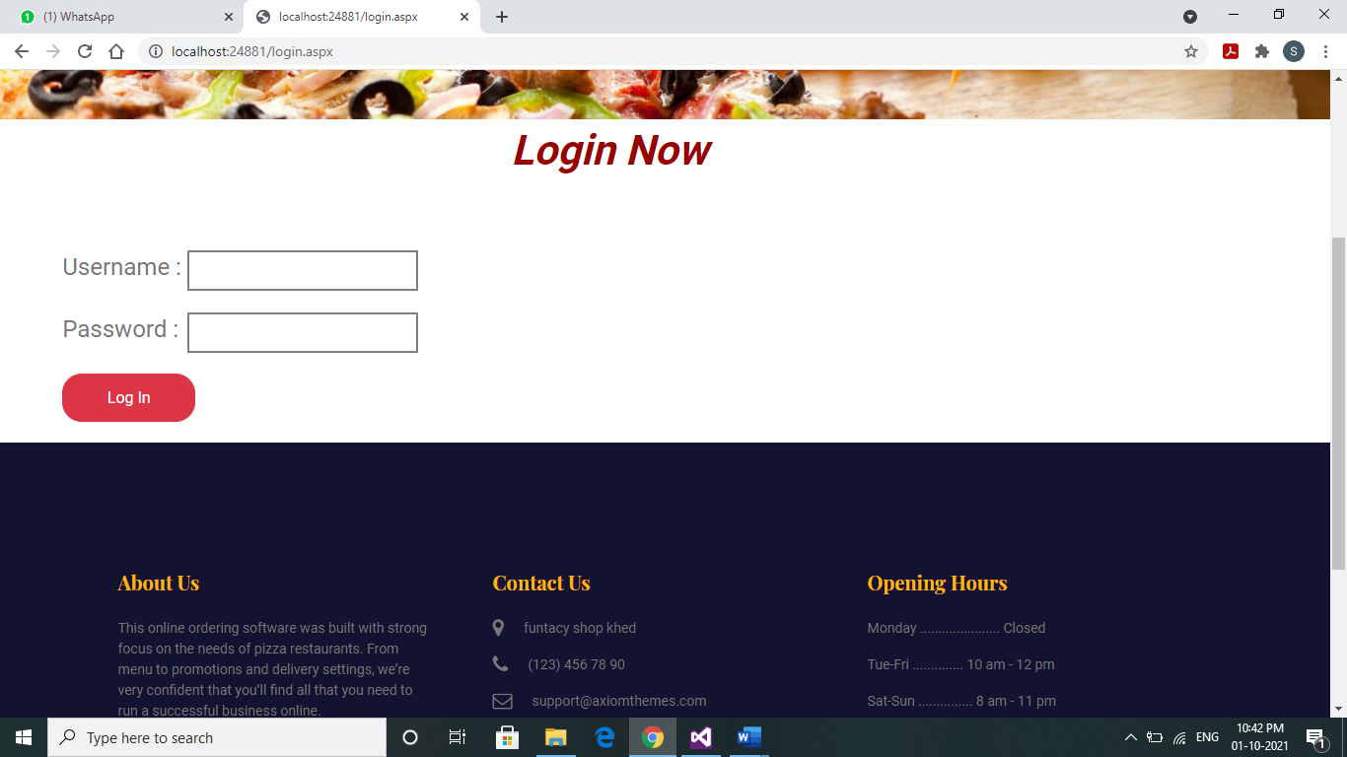

Contact

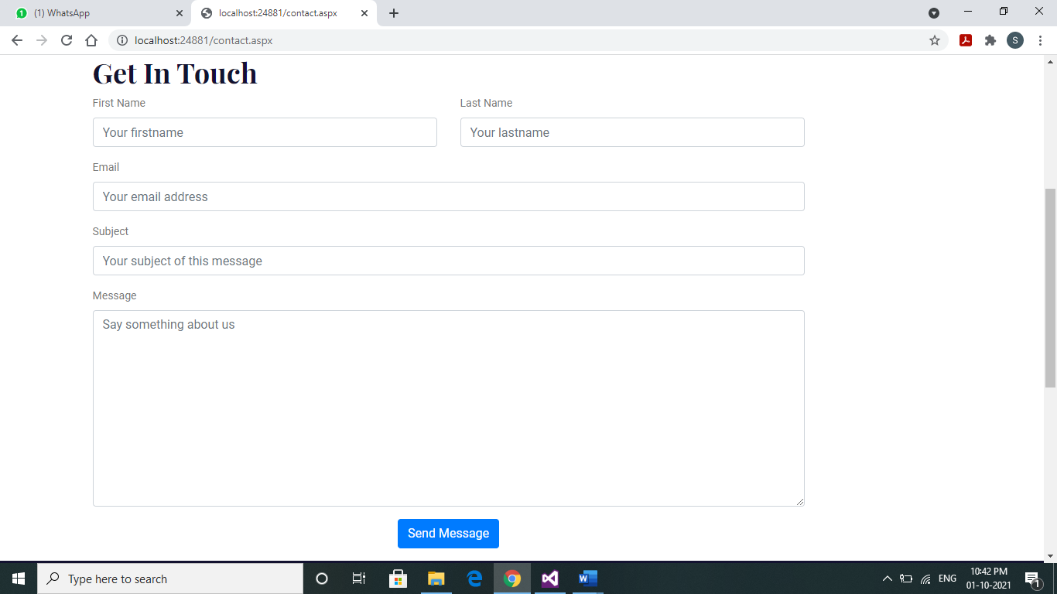

Our Menus

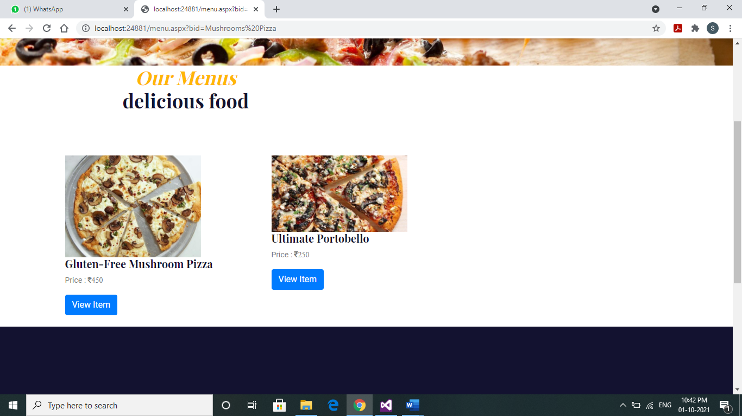

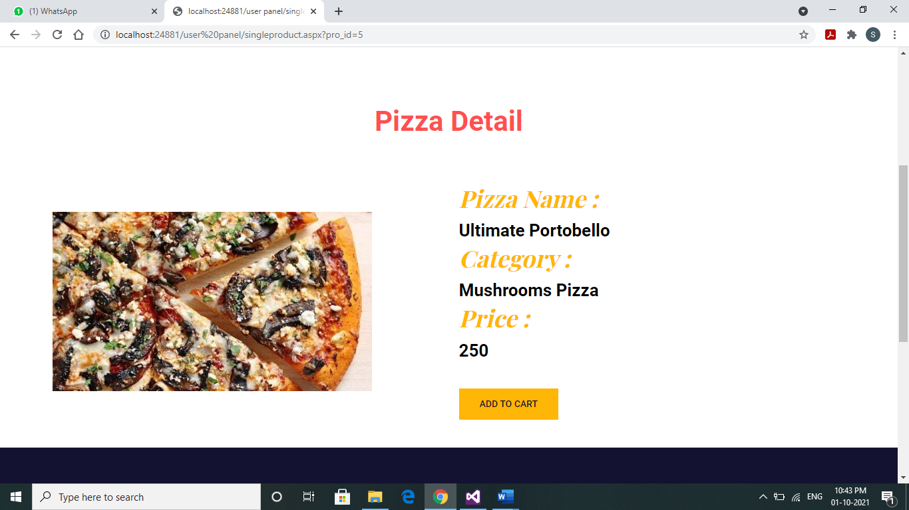

Shopping Cart

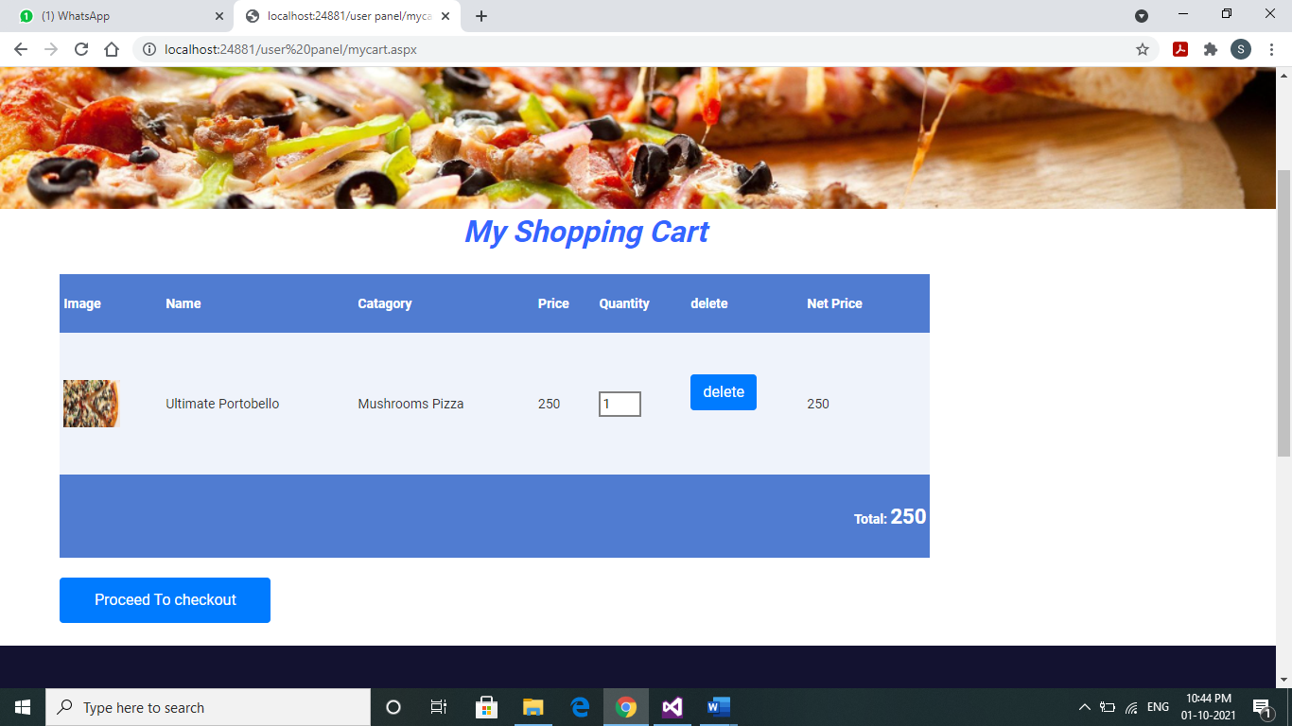

User Information

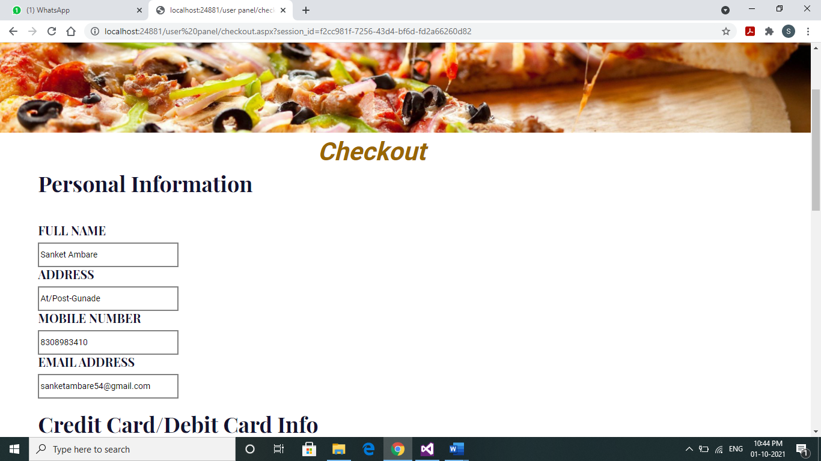

User Payment Method

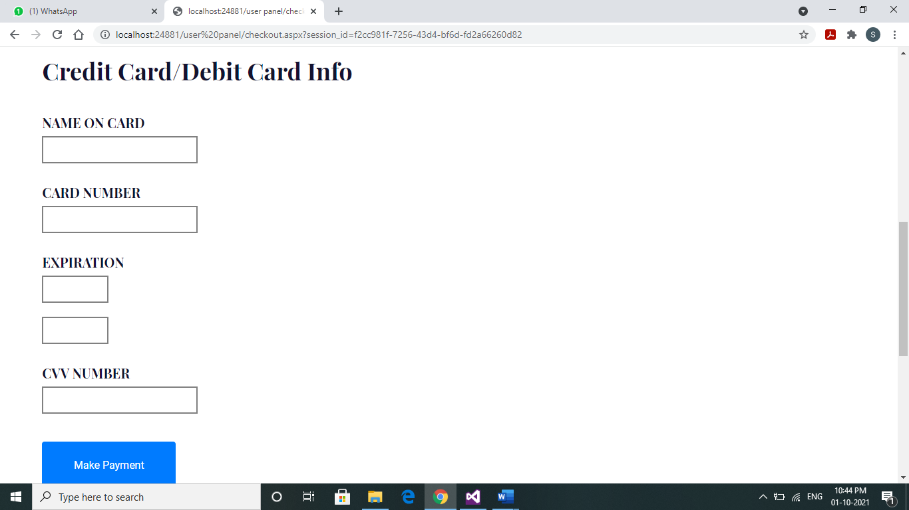

User Orders

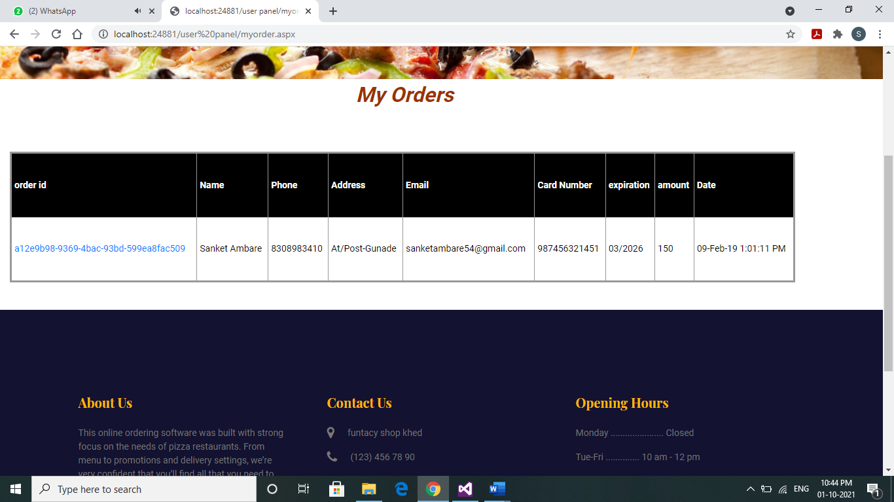

Users Order Summary

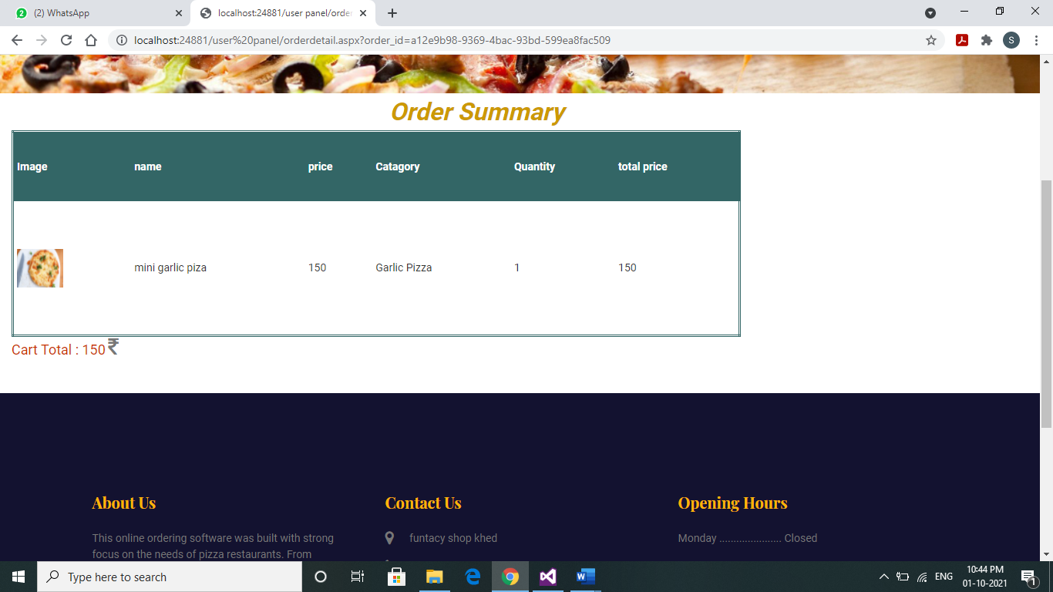

For Admin

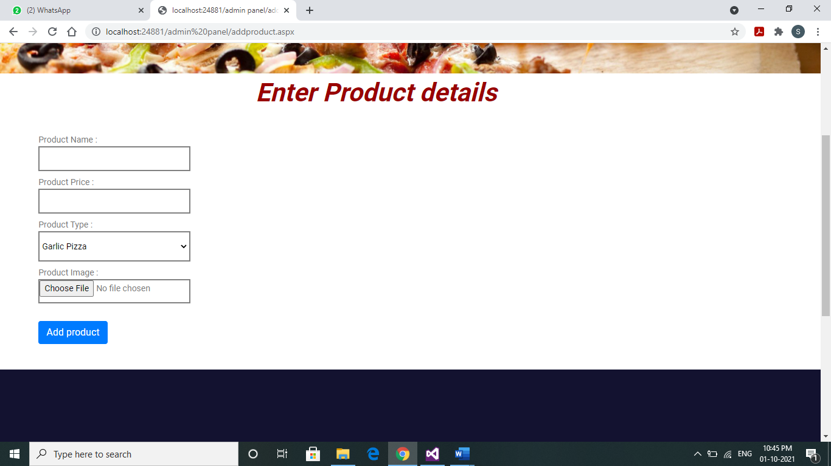

Edit Or Add product

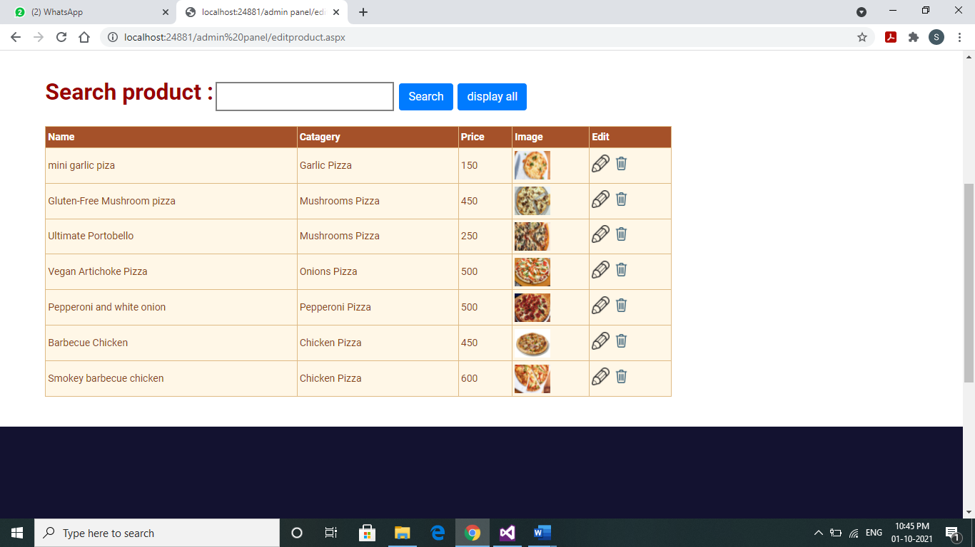

Orders checking

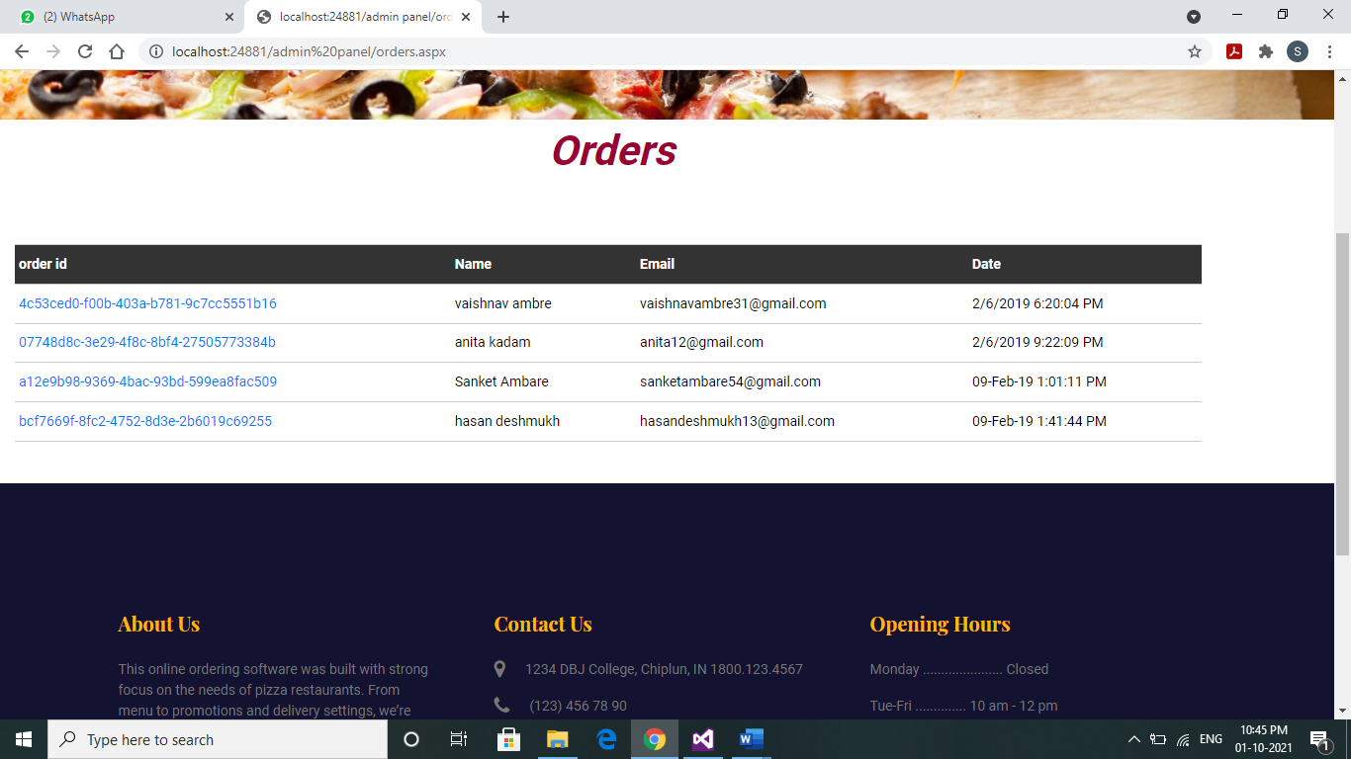

Order Details

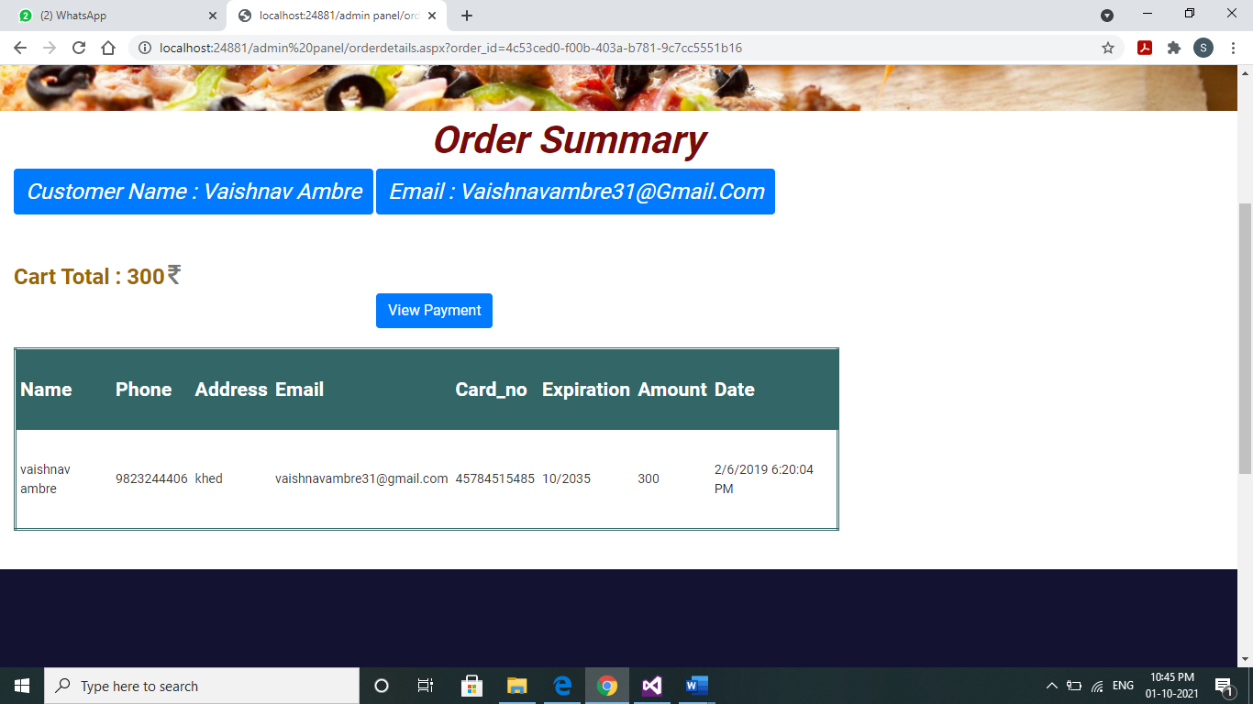

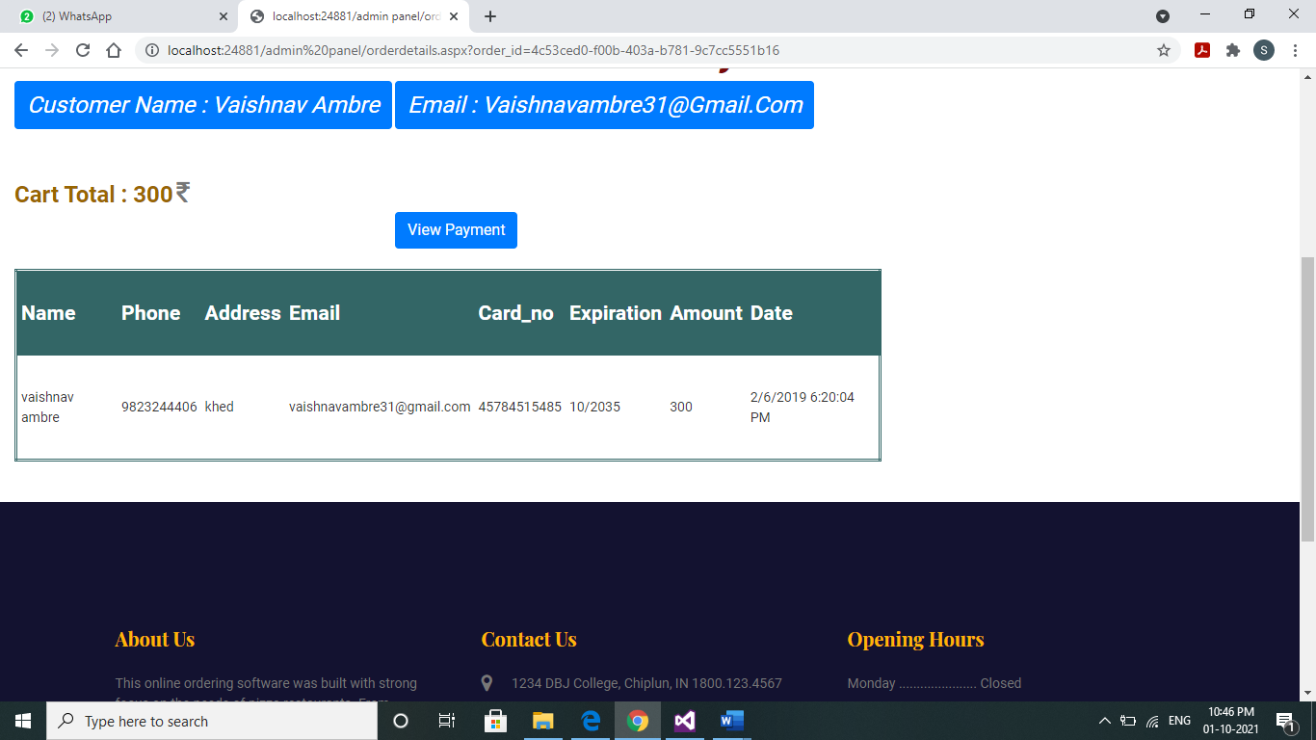

User Details

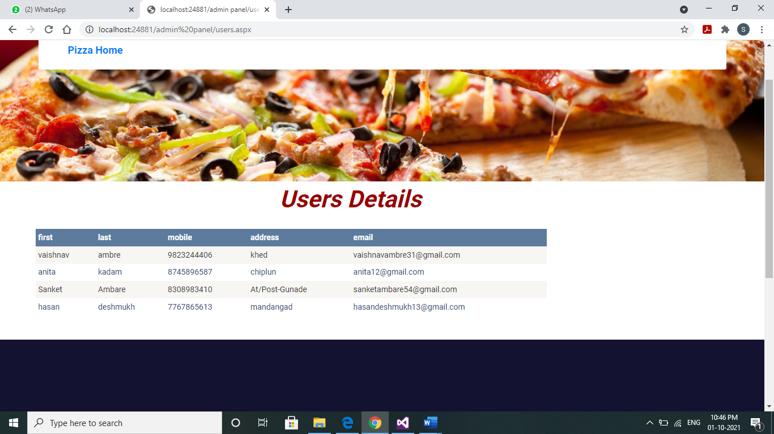

**CONCLUSION**

**AND**

**FUTURE WORK**

**Conclusion**

After having detail study on Online Fast Food one can see a grant change in the behavior of people in many manners like their attitude, buying pattern. In earlier times people use to do manual shopping but now as time changed people are becoming busy and due to which technology has brought a new revolution i.e., Online Shopping.

As we started doing survey it came to in notice that young age group people i.e., 15-30 uses or prefer online shopping because it is time and energy saving. But middle-age group does not prefer much because they have wrong perception that by seeing the product one can get the goods of proper quality. And even some people are prefer using plastic money i.e., credit cards.

But online shopping has a great future but to be successful it is necessary to spread awareness about its benefit.

**Future Work**

* The project made here is just to ensure that this product could be valid in today real challenging world. Here all the facilities are made and tested. Currently the system works for limited number of administrators to work. In future it will be extended for many types of insurance policies it that efficiency can be improved.
* In future I will add a payment gateway for secure payment and also added the cash on delivery.
* Also add the forget password system in the future implementation.

**REFERENCES**

**REFERENCES**

1. Beginning Asp.Net 4 in C# and VB.

2. The Complete reference ASP.Net

3. [www.youtube.com](http://www.youtube.com)